UNIFIED HEALTHCARE MANAGEMENT SYSTEM: INTEGRATING HOSPITAL DONOR AND PATIENT DATA
The Unified Healthcare Management System is a comprehensive web-based platform designed to seamlessly integrate hospital, donor, and patient data, streamlining the processes of organ and blood donation, patient matching, inventory management, and request handling. Healthcare plays a vital role in ensuring the well-being of individuals, and the effective coordination between hospitals, donors, and patients significantly enhances the quality of care. Historically, medical records and donor-patient coordination were handled manually using paperwork, telephonic communication, and fragmented databases, which often led to delays, data inconsistencies, and limited accessibility. Traditional systems lacked centralized storage, real-time updates, and automated donor-patient matching, causing inefficiencies in critical medical situations. Earlier solutions relied on physical record-keeping and local hospital databases that were not interconnected, making it difficult to access donor availability or match organ compatibility promptly. The motivation behind developing a unified solution stems from the urgent need to address delays in donor matching, untracked inventory, and manual errors in the current healthcare infrastructure. Rapid technological advancements and increased reliance on digital healthcare services inspired the creation of a centralized, automated platform to overcome the existing limitations. Problems such as lack of real-time donor data, inefficient matching processes, unorganized medical inventories, and communication gaps have often resulted in lost opportunities to save lives. The proposed system offers an efficient, web-based solution that enables role-based access for patients, donors, and hospital staff, facilitates registration, tracks blood and organ availability, manages donation and request workflows, and ensures secure, timely matching of donors and patients. Integrated alerts and approval mechanisms further enhance the decision-making process, while a user-friendly interface improves accessibility and adoption across healthcare providers. By centralizing data and introducing automation, this platform significantly reduces delays and enhances overall medical responsiveness and transparency.

CHAPTER – 1
INTRODUCTION

Introduction
In the current healthcare landscape, the integration of hospital, donor, and patient data is essential to ensure timely and effective medical intervention. With the rise in critical health conditions such as organ failure, chronic illnesses, and emergency injuries, the need for a system that enables immediate donor-patient matching and real-time medical data access has become more urgent than ever. Managing donor information, patient records, and inventory across different departments within hospitals has traditionally been a cumbersome and error-prone process. Often, essential data is stored in isolated systems, leading to delays in treatment, lack of synchronization, and miscommunication between healthcare providers.
A unified healthcare platform offers a comprehensive approach to bridging the gap between hospitals, donors, and patients by integrating all essential operations into a single digital interface. Donors are able to register and manage their blood or organ donation status, while hospitals can monitor available inventory and match it with pending patient needs. Patients benefit by submitting their requests, viewing statuses, and receiving timely updates regarding their cases. The complete system operates through a structured access model that ensures appropriate interaction between different users.
1.2 Research Motivation
The growing challenges faced by hospitals in coordinating donor and patient data inspired the design of a unified healthcare platform. Traditional methods often lead to delays in treatment due to the inability to quickly locate suitable donors or verify medical compatibility. Rising numbers of accident cases, chronic illnesses, and organ failure situations have highlighted the need for a system that responds faster and ensures data accuracy. Healthcare professionals frequently encounter hurdles caused by disconnected systems, such as outdated donor records or untraceable inventory data.
The lack of integration among various hospital departments often leads to mismanagement of resources and missed opportunities to save lives. Observations of real-life situations where timely access to blood or organ donors could have made a difference drove the vision to create a streamlined platform. The concept is reinforced by the increasing demand for centralized patient records, automated inventory tracking, and consistent donor engagement.
Implementing a solution that bridges the gaps in communication, reduces human dependency, and enhances trust among users emerged as a clear goal. The focus on a full-stack implementation using Python and Django ensures a robust, scalable, and flexible structure that can be easily maintained and extended. The system aims to eliminate inefficiencies and enhance decision-making through real-time access to critical medical data.
1.3 Problem Definition
Hospitals and healthcare institutions that operate without a centralized digital system face significant challenges. Manual processes used in storing donor and patient records result in frequent delays, misplaced data, and duplication errors. In many hospitals, the coordination between departments is limited, making it difficult to manage donor availability, inventory levels, and patient needs effectively. During medical emergencies, doctors are forced to rely on outdated records or incomplete information, leading to delayed responses and inefficient treatment plans.
Organ and blood request approvals are often done through phone calls or offline meetings, introducing delays and risking patient safety. Without automated tracking, hospitals face difficulties in maintaining accurate inventory data, causing either shortages or oversupplies. Donors are not properly informed or engaged due to the lack of digital tracking systems, resulting in fewer active donations and inconsistent support.
Compatibility between donor and patient profiles is verified manually, consuming time and leaving room for human error. There is no streamlined mechanism for updating records, sharing alerts, or managing requests. Additionally, data security and integrity are compromised in traditional systems due to reliance on physical documents or unprotected files. These limitations significantly impact the ability of hospitals to deliver timely, efficient, and life-saving care.
1.4 Significance
The integration of hospital, donor, and patient data into a centralized system plays a vital role in modern healthcare. Addressing inefficiencies found in manual and semi-digital systems brings immense value to both medical professionals and patients. A unified platform offers real-time access to donor availability and patient health records, enabling quick and accurate decisions, especially in emergencies. Hospitals gain the ability to monitor and manage inventory more efficiently, reducing wastage and ensuring critical resources are available when needed. The structured workflow minimizes miscommunication and automates approvals, saving time for medical staff and improving patient outcomes. Data accuracy is greatly enhanced, allowing healthcare providers to rely on up-to-date records during treatment planning and donor matching.
Donors receive clear communication regarding their contribution status, and patients experience faster processing of their requests. Hospitals can better track their overall performance and plan future resource allocation using system-generated reports and logs. By eliminating dependency on manual record-keeping and decentralization, the quality of healthcare services is significantly improved. This transformation enhances transparency, builds trust, and promotes collaboration among all stakeholders involved.
1.5 Applications
1. Used by hospitals to manage blood and organ inventory in real-time.
2. Allows patients to submit requests for blood or organ donations through secure web forms.
3. Enables donors to register and manage their donation preferences and availability.
4. Provides hospital administrators with tools to approve or reject donation requests.
5. Alerts donors during emergencies when their donation is needed.
6. Tracks patient medical history and treatment status in an organized digital format.

CHAPTER 2
LITERATURE SURVEY
[1] Ganikos M discusses the foundational landscape of organ donation by exploring the psychological and societal aspects involved in decision-making. He highlights how applied behavioral science can help shape public attitudes and foster greater understanding of the donation process. His work also emphasizes the importance of integrating education and outreach into healthcare strategies to encourage voluntary organ contribution. The study provides a comprehensive framework for understanding motivations and hesitations among potential donors.
[2] The U.S. Department of Health and Human Services outlines the functioning and data-driven insights of the Organ Procurement and Transplantation Network. It presents national statistics, trends, and organizational structures that support the allocation of organs across the United States. Their information system ensures transparency, fairness, and efficiency in organ distribution. The report serves as a key reference for understanding regulatory practices and their role in improving transplant outcomes.
[3] Anantachoti P, Gross CR, and Gunderson S explore the effectiveness of educational interventions aimed at high school students to promote awareness and positive attitudes toward organ donation. Their findings indicate a significant increase in willingness to register as organ donors after exposure to structured learning modules. The research supports the idea that early education can shape long-term health behaviors. It also recommends integrating donation-related content into academic curricula.
[4] Birkimer JC and colleagues examine how message framing, cognitive engagement, and time constraints influence decisions to become organ donors. Their work shows that individuals are more likely to consent to donation when presented with emotionally persuasive and logically counter-argued messages. The study also reveals that decision-making under deadlines can positively affect commitment. These findings are valuable for designing communication strategies in public health campaigns.
[5] Cantarovich F and his team argue that structured school education serves as a foundation for building positive attitudes toward organ donation. They advocate for including organ donation awareness in health education programs to reduce misconceptions and social stigma. Their research shows that informed students are more receptive to the concept of donation. This highlights the critical role of academic institutions in fostering a donation-supportive culture.
[6] Carducci BJ et al. apply the psychological technique known as "foot-in-the-door" to promote organ donation. By securing small initial commitments, such as discussing donation, they successfully increased full registration willingness. Their study provides a practical framework for gradual persuasion techniques. It emphasizes behavioral momentum as a tool for encouraging pro-social health decisions.
[7] Kopfman JE and Smith SW conduct a discriminant analysis to understand different audience segments based on their intent to donate organs. Their findings reveal that demographic and psychological profiles significantly affect donation attitudes. This segmentation allows for better-targeted communication strategies. Their study emphasizes tailoring messages to specific audience motivations.
[8] Kopfman JE, Smith SW, Ah Yun JK, and Hodges A investigate how people respond emotionally and intellectually to different types of donation messages. Their study compares narrative storytelling with statistical evidence and concludes that stories are more persuasive and memorable. They suggest that emotional narratives can build empathy and trust among target audiences. The results are useful for designing effective health communication content.
[9] Radecki CM and Jaccard J provide a critical review of the psychological components influencing organ donation decisions, both at the individual and family levels. Their synthesis highlights factors like perceived risk, cultural beliefs, and family discussions as crucial determinants. They also discuss how policy and social environment interact with personal attitudes. This work offers valuable insight for designing interventions that address emotional and cognitive barriers.
[10] Smith SW and colleagues examine the impact of pre-existing thoughts and intentions on how organ donation messages are received and remembered. Their study indicates that individuals who already support donation are more receptive and retain message content more effectively. This reinforces the need to engage undecided individuals through emotionally compelling and personally relevant campaigns. Their analysis contributes to refining persuasive strategies in donation advocacy.
[11] Weaver M and co-authors assess the knowledge and perceptions of urban high school students regarding organ donation through a pilot education program. They find that targeted health education can significantly increase awareness and willingness to register as donors. The study also shows the importance of culturally relevant materials in reaching diverse populations. Their work supports the role of early and inclusive education in shaping donation behavior.

CHAPTER 3
TRADITIONAL SYSTEM
3.1 Manual Record-Keeping System
In many hospitals, donor and patient records were historically maintained in physical registers or files. Medical staff recorded patient history, blood group, organ compatibility, and donation records manually. Each department had its own record books, resulting in scattered data and duplication. Retrieval of information during emergencies often led to delays, as staff had to physically search through files. Maintaining updated data was difficult, and expired or outdated records were rarely filtered out. There was no standardization in how records were kept, leading to inconsistencies across departments. As the volume of patients and donors increased, the limitations of paper-based systems became more evident. There were also issues of physical damage, loss, or unauthorized access to sensitive information.
3.2 Isolated Departmental Software
Some healthcare institutions adopted individual software systems within specific departments like blood banks, emergency care, or outpatient services. These systems were not interconnected, causing data silos across departments. For example, the blood bank might have had a system to track donors and available stock, but it wasn't linked to the patient database in the emergency room. As a result, doctors and nurses had to contact departments manually or through phone calls to verify availability or status. These systems often lacked centralized user authentication, making it hard to track who accessed or modified information. Report generation was basic, and syncing data across departments required manual export and import processes. This led to coordination issues and delays in critical decision-making.
3.3 Telephonic and Paper-Based Donor Coordination
Blood and organ donation processes were largely managed through offline campaigns and telephone communication. Hospitals or non-governmental organizations organized donor drives and kept lists of willing donors in physical notebooks. During medical emergencies, staff members called donors individually to check availability. There was no structured or verified system to match patients with suitable donors quickly. Delays in reaching donors or verifying their eligibility led to missed opportunities for treatment. Also, there was no easy way to alert a wide group of donors at once. The absence of a reliable digital medium meant that updates on availability or health condition of donors were not maintained consistently. This made donor engagement irregular and inefficient.
3.4 Basic Spreadsheet-Based Tracking
In some institutions, healthcare staff maintained spreadsheets to manage donor and patient records. While this method offered slightly better organization than paper, it still lacked scalability and security. Updating spreadsheets required manual effort, and there were no built-in mechanisms for real-time collaboration or user-based access control. Compatibility checks between donor and patient were done separately, without integrated logic or automatic matching. Errors in data entry, accidental deletions, and version mismatches were common. Since spreadsheets were often shared via emails or stored on local computers, they lacked centralized backups. This method failed to support real-time notifications or structured workflows for request approval and donor communication.
Overall Drawbacks of Traditional Systems
1. Lack of integration between departments leads to delays in accessing critical donor or patient data.
2. Manual systems are prone to data loss, physical damage, and unauthorized access.
3. Emergency cases face treatment delays due to absence of real-time donor-patient matching mechanisms.
4. Paper-based or spreadsheet systems offer no structured workflows for approvals or alerts.
5. Donor information is not updated frequently, causing inaccuracies and inefficiencies in communication.
6. There is no centralized dashboard for hospital staff to view real-time inventory or pending requests.

CHAPTER 4
PROPOSED SYSTEM
PROPOSED SYSTEM
4.1 Overview
The unified healthcare management system ensures seamless integration of hospital, donor, and patient data through a centralized web-based application developed using full-stack Python with Django. It facilitates efficient handling of medical records, blood and organ donor databases, and patient treatment information under a single platform. Real-time access and updates are provided for authorized hospital staff, enhancing coordination across departments. The system allows donors to register and update their availability, while patients can be matched instantly based on compatibility and urgency. Request handling, donor approval, and status tracking are streamlined through role-based access. Data security is maintained using authentication and structured user roles, ensuring that sensitive information is protected. The platform also supports alerts for low inventory, emergency needs, and upcoming donor follow-ups. By eliminating redundancy and automating matching and communication processes, the system significantly improves decision-making speed and treatment efficiency in critical situations.
4.2 Key Features and Functionalities
The unified healthcare management system incorporates a wide range of features aimed at enhancing healthcare data coordination and accessibility. Key functionalities include role-based access for hospitals, patients, and donors, ensuring secure and structured usage. A real-time donor-patient matching mechanism is implemented to quickly identify compatible organ and blood donors. The system supports secure donor registrations, medical history uploads, and consent management. Hospitals can update inventory and manage blood and organ requests through an intuitive dashboard. Alerts and notifications are triggered for low inventory or emergency requirements. The platform also includes search and filter capabilities for donor availability and request history. Every transaction and request is recorded for transparency and future reference. Additionally, the interface is designed for ease of navigation, ensuring users from different backgrounds can efficiently interact with the system.
4.3 Technical Implementation (MVT)

Models (M) – Data Structure
- User Model
  - Fields: username, password, email, role, mobile
  - Purpose: Extends the default AbstractUser model to add roles (admin, donor, patient, staff) and mobile number.
- Blood Model
  - Fields: name
  - Purpose: Represents different types of blood groups (e.g., A+, B-, O+).
- Donor Model
  - Fields: user, category, blood_type, organ, last_donation, donated
  - Purpose: Represents a donor, linked to the User model, with details about the category (blood/organ), blood type, and last donation date.
- Patient Model
  - Fields: user, date_of_birth, gender, blood_type, chronic_conditions, medications, emergency_contact, required, last_checkup_date, status
  - Purpose: Represents a patient with detailed health information, including the blood type and conditions.
- BloodInventory Model
  - Fields: blood_type, quantity, last_updated
  - Purpose: Stores available blood stock in the inventory.
- BloodRequest Model
  - Fields: patient, blood_type_needed, quantity_needed, status, request_date
  - Purpose: Represents blood requests made by patients, including status and details of the required blood type.
- OrganRequest Model
  - Fields: patient, blood_type, organ_needed, status, request_date
  - Purpose: Represents organ requests made by patients.
- MatchDonation Model
  - Fields: patient, donor, status
  - Purpose: Represents the matching of donors to patients for either blood or organ donation.

Views (V) – Business Logic
- Home View (home)
  - Purpose: Displays the home page of the application.
- Registration View (register)
  - Purpose: Handles the registration of users (donor, patient, staff, or admin). Ensures password validation and user creation based on selected roles.
- Login View (login_view)
  - Purpose: Handles user login using credentials.
- Logout View (logout_view)
  - Purpose: Logs out the current user and redirects to the home page.
- Add Patient View (add_patient)
  - Purpose: Allows adding a new patient, including health details like blood type, medications, and chronic conditions.
- Add Donor View (add_donor)
  - Purpose: Allows adding a new donor, including blood type, organ donation preference, and last donation date.
- Blood Request View (blood_request)
  - Purpose: Allows patients to request blood based on their required blood type and quantity.
- Organ Request View (organ_request)
  - Purpose: Allows patients to request organs based on their need.
- Blood Inventory View (blood_inventory)
  - Purpose: Displays and manages the blood inventory. Allows the addition of blood types and quantities.
- Check Match View (checkmatch)
- Purpose: Matches donors to patients based on required blood or organs. Provides information about available donors and blood inventory.
- Match View (match_view)
- Purpose: Creates a match between a donor and a patient for either blood or organ donation.
- Accept Match View (accept)
- Purpose: Accepts a donation match, changing the status of the match to "Approved."
- Patient Info View (patient_info)
- Purpose: Displays information about all patients.
- Donor Info View (donor_info)
- Purpose: Displays information about all donors.
- History View (request)
- Purpose: Shows the history of requests made by the current user (patient or donor).

Templates (T) – User Interface
- home.html
  - Displays the homepage with basic navigation and user options.
- register.html
  - Registration form for creating new users with role-based registration options (patient, donor, staff).
- login.html
  - Login form for authenticating users.
- patient.html
  - Displays a form to add a patient, including necessary health details and the option to request blood or organs.
- donor.html
  - Displays a form to add a donor, including blood type and organ donation details.
- bloodrequest.html
  - Form for patients to request blood, displaying available blood types and allowing submission of blood request.
- organrequest.html
  - Form for patients to request an organ, displaying available organ options.
- bloodinventory.html
  - Displays the blood inventory and provides functionality to add/update blood stock.
- checkmatch.html
  - Displays a list of patients and donors, along with the matching blood/organ donors based on patient needs.
- Matchview.html
- Allows the user to view details about matched donations.
- userinfo.html
- Displays user information for both patients and donors.
- addblood.html
- Form to add new blood types to the system.

Additional Implementation Details
● URL Routing (urls.py):
○ Maps all views to specific routes.
○ Handles file/media serving with static(settings.MEDIA_URL, document_root=settings.MEDIA_ROOT).
● Messages Framework:
○ Used to provide real-time feedback (e.g., successful registration, error messages).
● Login Protection:
○ @login_required decorator restricts access to certain views (e.g., certificate approval).
4.4 Django Framework
Django is a robust and scalable Python-based web framework that promotes rapid development, code reusability, and clean application design. It simplifies web development by offering a suite of tools and built-in modules such as authentication, form handling, database abstraction through ORM, and admin interfaces. Django’s security features help protect against common threats like CSRF, XSS, and SQL injection. The framework also encourages best practices such as DRY (Don’t Repeat Yourself) and includes middleware support to handle tasks like session management and request processing efficiently. It is ideal for building large-scale applications with multiple user interactions and layered functionalities, as required in secure voting systems.
Core Components of Django
· Models define the structure of database tables and manage data through Python classes
· Views handle all application logic and manage data interaction between the model and template
· Templates are responsible for displaying dynamic HTML content to users
· URL Dispatcher maps incoming requests to the appropriate views through clean and readable patterns
· Forms simplify user input collection and validation, ensuring smooth interaction
· Admin Interface offers out-of-the-box data management without needing to build a back-end dashboard manually
· Middleware processes requests and responses globally, improving performance and adding extra layers of protection
· Settings and Configuration provide centralized control for managing installed apps, templates, databases, and more
4.5 HTML and CSS
HTML (HyperText Markup Language) serves as the backbone for designing the structure and layout of the web interface, while CSS (Cascading Style Sheets) is used to define and enhance the presentation of these elements. In the centralized online voting system, HTML is utilized to create all static and dynamic user-facing components including registration forms, login pages, dashboard layouts, voting buttons, alert interfaces, and confirmation popups. Each form is carefully structured with user-friendly tags to support input validation and accessibility. Semantic HTML elements ensure that the web pages are easy to navigate and visually clear.
CSS enhances the appearance of these components by applying visually consistent styles, such as custom color schemes, rounded input fields, interactive buttons, and smooth layout transitions. Responsive design principles are followed using media queries, enabling the application to work flawlessly across desktops, tablets, and mobile screens. CSS grid and flex-box techniques are used for clean alignment, spacing, and adaptive sizing of elements. Custom styling ensures that the platform not only performs efficiently but also looks modern and intuitive, encouraging active participation from users. Additionally, animations and hover effects are implemented to make the user interface more engaging without compromising load time or accessibility.
By using HTML and CSS in combination, the entire voting platform is made visually appealing, accessible to all user levels, and structured in a way that promotes easy navigation, quick responses, and a professional feel throughout every interaction page.
4.6 Integration of Django, HTML, and CSS
The integration between Django, HTML, and CSS creates a unified environment where backend logic seamlessly interacts with frontend presentation. Django handles server-side logic and data operations such as user registration, login validation, OTP verification, vote submission, and alert notifications. Through its template rendering engine, Django dynamically injects data into HTML templates, allowing personalized and context-aware content to appear on the screen. For example, logged-in users see custom messages, real-time voting statistics, and alerts relevant to their activity.
CSS is incorporated into the Django project using the framework’s static file configuration. Stylesheets are linked through the base template and shared across all sub-templates to maintain consistent theming and appearance. The use of base.html and template inheritance in Django ensures that layout changes only need to be made in a single place to reflect across all pages, saving time and reducing errors.
Static files such as images, logos, and style scripts are managed using Django’s static directory setup, ensuring they are served securely and efficiently. Template tags like {% static %} and {% url %} allow seamless linking of resources and navigation paths, ensuring accurate rendering and proper redirection within the app.
This integration ensures that when users interact with the application—whether they’re verifying their account, casting a vote, or raising an alert—they experience a smooth, responsive, and visually consistent workflow. The technical harmony between Django's logic and the interface built with HTML and CSS makes the system both powerful and user-friendly, enabling law enforcement personnel to focus solely on the action at hand without being distracted by usability issues or performance glitches.

CHAPTER 5
UML DIAGRAMS
UML stands for Unified Modeling Language. UML is a standardized general-purpose modeling language in the field of object-oriented software engineering. The standard is managed, and was created by, the Object Management Group. The goal is for UML to become a common language for creating models of object-oriented computer software. In its current form UML is comprised of two major components: a Meta-model and a notation. In the future, some form of method or process may also be added to; or associated with, UML.
The Unified Modeling Language is a standard language for specifying, Visualization, Constructing and documenting the artifacts of software system, as well as for business modeling and other non-software systems. The UML represents a collection of best engineering practices that have proven successful in the modeling of large and complex systems. The UML is a very important part of developing objects-oriented software and the software development process. The UML uses mostly graphical notations to express the design of software projects.
GOALS: The Primary goals in the design of the UML are as follows:
· Provide users a ready-to-use, expressive visual modeling Language so that they can develop and exchange meaningful models.
· Provide extendibility and specialization mechanisms to extend the core concepts.
· Be independent of particular programming languages and development process.
· Provide a formal basis for understanding the modeling language.
· Encourage the growth of OO tools market.
· Support higher level development concepts such as collaborations, frameworks, patterns and components.
· Integrate best practices.

Class diagram
The class diagram is used to refine the use case diagram and define a detailed design of the system. The class diagram classifies the actors defined in the use case diagram into a set of interrelated classes. The relationship or association between the classes can be either an "is-a" or "has-a" relationship. Each class in the class diagram was capable of providing certain functionalities. These functionalities provided by the class are termed "methods" of the class. Apart from this, each class may have certain "attributes" that uniquely identify the class.

Figure-5.1: Class Diagram
Sequence Diagram
A sequence diagram in Unified Modeling Language (UML) is a kind of interaction diagram that shows how processes operate with one another and in what order. It is a construct of a Message Sequence Chart. A sequence diagram shows, as parallel vertical lines (“lifelines”), different processes or objects that live simultaneously, and as horizontal arrows, the messages exchanged between them, in the order in which they occur. This allows the specification of simple runtime scenarios in a graphical manner.

Figure-5.2: Sequence Diagram
Activity diagram
Activity diagrams are graphical representations of Workflows of stepwise activities and actions with support for choice, iteration, and concurrency. In the Unified Modeling Language, activity diagrams can be used to describe the business and operational step-by-step workflows of components in a system. An activity diagram shows the overall flow of control.

Figure-5.3: Activity Diagram
Data flow diagram
A data flow diagram (DFD) is a graphical representation of how data moves within an information system. It is a modeling technique used in system analysis and design to illustrate the flow of data between various processes, data stores, data sources, and data destinations within a system or between systems. Data flow diagrams are often used to depict the structure and behavior of a system, emphasizing the flow of data and the transformations it undergoes as it moves through the system.

Figure-5.4: Dataflow Diagram
Component diagram: Component diagram describes the organization and wiring of the physical components in a system.

Figure-5.5: Component Diagram
Use Case diagram: A use case diagram in the Unified Modeling Language (UML) is a type of behavioral diagram defined by and created from a Use-case analysis. Its purpose is to present a graphical overview of the functionality provided by a system in terms of actors, their goals (represented as use cases), and any dependencies between those use cases. The main purpose of a use case diagram is to show what system functions are performed for which actor. Roles of the actors in the system can be depicted.

Figure-5.6 Use Case Diagram:
Deployment Diagram:
The Deployment Diagram illustrates the physical architecture of the online cooking classes system, showing how software components are deployed on hardware. It includes the user device, which interacts with the system through a browser, the web server hosting the Django application, and the database server running SQLite. Interactions flow as the user's browser sends HTTP requests to the web server, which processes them, interacts with the SQLite database for data operations, and sends back appropriate responses to the user's browser.

Figure-5.7 Deployment Diagram

CHAPTER 6
SOFTWARE ENVIRONMENT
6.1 Overview
Python is a high-level, interpreted programming language known for its readability and ease of use. Created by Guido van Rossum and first released in 1991, Python emphasizes code readability and simplicity, which makes it an excellent choice for both beginners and experienced developers. Python's syntax is designed to be clean and straightforward, allowing developers to express concepts in fewer lines of code compared to other languages. Its versatile nature makes it suitable for a wide range of applications, including web development, data analysis, artificial intelligence, scientific computing, and more.
6.2 Features of Python
Python is characterized by its simplicity and readability, which stems from its clear and concise syntax. The language supports multiple programming paradigms, including procedural, object-oriented, and functional programming, providing flexibility to developers in structuring their code. Python's extensive standard library includes modules and packages for various tasks such as file I/O, system operations, web development, and more, reducing the need to write code from scratch. Dynamic typing and automatic memory management in Python eliminate the need for explicit declarations, simplifying code development and reducing errors. Furthermore, Python boasts a large and active community, contributing to a vast ecosystem of third-party packages and frameworks, enhancing its functionality and applicability.
6.3 Advantages of Python
Python's ease of learning and use is one of its primary advantages, making it accessible to beginners while powerful enough for experienced developers. Its extensive standard library and a rich ecosystem of third-party packages significantly accelerate development time, as many functionalities are readily available. Python's versatility allows it to be used across different domains and applications, from web development to machine learning and automation. Additionally, Python's strong community support ensures continuous improvement, regular updates, and a wealth of resources, such as documentation, tutorials, and forums. The language's cross-platform nature enables code to run seamlessly on various operating systems, including Windows, macOS, and Linux. Integration capabilities with other languages and tools, such as C, C++, and Java, further enhance Python's applicability in diverse projects.
6.4 Packages Used
Python packages play crucial roles in building and enhancing the application's functionality. Django is the primary web framework used for developing applications. It provides tools and components for URL routing, views, models, templates, and authentication, facilitating the rapid development of secure and scalable web applications.
Additionally, the django-crispy-forms package is used to enhance the appearance and functionality of Django forms. It provides tools for customizing form rendering, making forms more user-friendly and visually appealing. The Gunicorn package serves as the WSGI HTTP server for running the Django application in a production environment. It efficiently handles multiple requests and ensures smooth performance. Finally, for version control, Git is used to manage the project's codebase. It facilitates collaboration among developers, tracks changes, and allows for efficient branching and merging of code.

CHAPTER 7
SOFTWARE AND HARDWARE REQUIREMENTS
Software Requirements:
1. Operating System:
o Linux (Ubuntu, CentOS) or macOS for development and deployment. Windows can also be used, but Linux is more commonly recommended for production environments.
2. Python:
o Version 3.x (e.g., Python 3.8 or 3.9). Django supports Python 3.6 and later versions.
3. Django:
o Django framework installed via pip. Use the latest stable version recommended for production deployments.
pip install django
4. Database:
o PostgreSQL (recommended for production) or MySQL for storing application data.
o SQLite (default in Django) can be used for development but not recommended for production.
5. Web Server:
o Gunicorn (or uWSGI) as a WSGI HTTP server interface to serve Python web applications.
6. Version Control:
o Git for version control and managing project codebase.
7. IDE/Text Editor:
o Recommended IDEs include PyCharm, VS Code, Sublime Text, or any editor of choice suitable for Python development.
Hardware Requirements:
1. Development Machine:
o Modern laptop or desktop with at least 8GB RAM and a multi-core processor (Intel i5 or equivalent).
o Adequate storage for development tools and project files.
2. Production Server:
o Virtual Private Server (VPS) or dedicated server with sufficient resources:
§ Minimum 2GB RAM (4GB recommended for better performance).
§ Dual-core processor or higher.
§ SSD storage for better I/O performance.
§ Adequate bandwidth based on expected traffic.
3. Database Server:
o Separate server or instance for hosting PostgreSQL or MySQL database:
§ Aligned with production server specifications (RAM, CPU, storage).
These requirements ensure that the Django application runs smoothly, handles concurrent user interactions efficiently, and maintains data integrity and security. Adjustments may be necessary based on specific project needs and expected traffic levels.
CHAPTER 8
FUNCTIONAL REQUIREMENTS

1. Home View
- Function: Display the home page.
- URL: /
- Template: home.html
- Actions:
  - Renders the homepage template.

2. Login View
- Function: Handle user login.
- URL: /login
- Method: POST
- Template: login.html
- Actions:
  - Authenticate the user with the provided credentials.
  - On successful login, redirect to the home page.
  - On failure, redirect back to the login page with an error message.

3. Logout View
- Function: Log out the current user.
- URL: /logout
- Template: None (Redirects)
- Actions:
  - Logs out the user.
  - Redirects to the login page.

4. Register View
- Function: Register a new user (donor, patient, or admin).
- URL: /add-role
- Template: register.html
- Actions:
  - Displays a registration form.
  - Saves user and role-based data.
  - Redirects to the login page on success.

5. Patient Info View
- Function: Display all patient information.
- URL: /patients-info/
- Template: patients_info.html
- Actions:
  - Retrieves and displays a list of all registered patients.

6. Add Patient View
- Function: Add a new patient.
- URL: /add-patient
- Template: add_patient.html
- Actions:
  - Provides a form to input patient details.
  - Saves the patient data to the database.

7. Add Donor View
- Function: Add a new donor.
- URL: /add-donor
- Template: add_donor.html
- Actions:
  - Displays a form to input donor details.
  - Saves donor information to the database.

8. Donor Info View
- Function: Display donor details.
- URL: /donor-info/
- Template: donor_info.html
- Actions:
  - Lists all registered donors and their relevant information.

9. Add Blood Group View
- Function: Add blood group to inventory.
- URL: /add-blood/
- Template: add_blood.html
- Actions:
  - Shows a form for adding new blood group entries.
  - Updates the blood inventory on form submission.

10. Blood Request View
- Function: Submit a blood request.
- URL: /blood-request
- Template: blood_request.html
- Actions:
  - Provides a form for patients to request blood.
  - Stores the request and notifies admins.

11. Organ Request View
- Function: Submit an organ request.
- URL: /organ-request
- Template: organ_request.html
- Actions:
  - Allows patients to request specific organs.
  - Saves the request for approval/matching.

12. Blood Inventory View
- Function: View blood stock.
- URL: /blood-inventory/
- Template: blood_inventory.html
- Actions:
  - Displays current available blood units grouped by type.

13. Check Match View
- Function: Match donor and patient data.
- URL: /checkmatch
- Template: check_match.html
- Actions:
  - Runs logic to check compatibility between donors and patients.
  - Displays match results or suggestions.

14. Match View
- Function: Show matched records
- URL: /match_view
- Template: match_view.html
- Actions:
  - Lists all current donor-patient matches.
  - Includes request and approval details.

15. Accept Match View
- Function: Accept a matched request.
- URL: /accept/<int:pk>/
- Template: accept_match.html
- Actions:
  - Retrieves match request by primary key (ID).
  - Marks it as accepted and updates the database accordingly.

CHAPTER 9
SOURCE CODE
from django.shortcuts import render, get_object_or_404, redirect
from django.contrib.auth.decorators import login_required
from django.contrib import messages
from .models import Donor, Patient, BloodInventory, BloodRequest,blood,match_donoation
from .models import User
from django.contrib.auth import login,logout,authenticate
# Home View
def home(request):
return render(request, 'home.html')
def register(request):
if request.method == 'POST':
first_name = request.POST['name']
email = request.POST['email']
username = request.POST['username']
password = request.POST['password']
confirmation_password = request.POST['cnfm_password']
role = request.POST['role'] # Fetch role correctly
print("Role selected:", role)
if password == confirmation_password:
if User.objects.filter(username=username).exists():
messages.error(request, 'Username already exists, please choose a different one.')
return redirect('register')
elif User.objects.filter(email=email).exists():
messages.error(request, 'Email already exists, please choose a different one.')
return redirect('register')
else:
# Create the user (without 'role' as User model doesn't have it)
user = User.objects.create_user(
username=username,
password=password,
email=email,
first_name=first_name,
role=role,
)
user.save()
if role == 'patient':
blood_types = blood.objects.all()
userinfo = User.objects.filter(role=role).order_by('-id') # Fetch latest users
return render(request, "patient.html", {"blood_types": blood_types, 'userinfo': userinfo})
elif role == 'donor':
userinfo = User.objects.filter(role=role).order_by('-id')
blood_types = blood.objects.all()
return render(request, 'donor.html', {"blood_types": blood_types, 'users': userinfo})
else:
messages.success(request, f'Successfully added new user: {username}')
return redirect('register')
else:
messages.error(request, 'Passwords do not match.')
return redirect('register')
return render(request, 'register.html')

def login_view(request):
if request.method == 'POST':
username = request.POST['username']
password = request.POST['password']
user = authenticate(request, username=username, password=password)
if user is not None:
login(request, user)
return redirect('home')
else:
messages.error(request, 'please check the password...')
return redirect('login')
return render(request, 'login.html')

def logout_view(request):
logout(request)
return redirect('home')

def add_patient(request):
blood_types = blood.objects.all()
userinfo=User.objects.filter(role='patient').order_by('-id')
if request.method == "POST":
person = request.POST.get('id')
date_of_birth = request.POST.get("date_of_birth")
gender = request.POST.get("gender")
blood_type_id = request.POST.get("blood_type")
chronic_conditions = request.POST.get("chronic_conditions")
medications = request.POST.get("medications")
emergency_contact = request.POST.get("emergency_contact")
last_checkup_date = request.POST.get("last_checkup_date")
required=request.POST['required']
blood_type = blood.objects.get(id=blood_type_id)
p=User.objects.get(id=person)
patient, created = Patient.objects.update_or_create(
user=p,
defaults={
"date_of_birth": date_of_birth,
"gender": gender,
"blood_type": blood_type,
"chronic_conditions": chronic_conditions,
"medications": medications,
"emergency_contact": emergency_contact,
"last_checkup_date": last_checkup_date,
"required":required,
}
)
patient = Patient.objects.filter(required='Blood').order_by('-id')
blood_types = blood.objects.all()
if required == 'Blood':
return render(request, "bloodrequest.html", {"blood_types": blood_types,'patient':patient})
else:
return render(request,'organrequest.html', {"blood_types": blood_types,'patient':patient})
return render(request, "patient.html", {"blood_types": blood_types,'userinfo':userinfo})
from django.shortcuts import render, redirect
from .models import Donor, User,blood

def add_donor(request):
if request.method == 'POST':
user_id = request.POST.get('user')
category= request.POST.get('category')
blood_type_id = request.POST.get('blood_type')
organ = request.POST.get('organ', '')
last_donation = request.POST.get('last_donation')
userinfo = User.objects.get(id=user_id)
blood_type_obj = blood.objects.get(id=blood_type_id)
Donor.objects.create(
user=userinfo,
category=category,
blood_type=blood_type_obj,
organ=organ,
last_donation=last_donation if last_donation else None,
)
return redirect('donor_info')
users = User.objects.filter(role='donor').order_by('-id')
blood_types = blood.objects.all()
return render(request, 'donor.html', {
'users': users,
'blood_types': blood_types
})

from django.shortcuts import render, redirect
from .models import BloodRequest, blood, Patient
from django.contrib.auth.decorators import login_required

@login_required
def blood_request(request):
patient = Patient.objects.filter(required='Blood').order_by('-id')
blood_types = blood.objects.all()
if request.method == "POST":
p= request.POST.get("patient")
blood_type_id = request.POST.get("blood_type_needed")
quantity_needed = request.POST.get("quantity_needed")
blood_type = blood.objects.get(id=blood_type_id)
BloodRequest.objects.create(
patient=Patient.objects.get(id=p),
blood_type_needed=blood_type,
quantity_needed=quantity_needed
)
return redirect('blood_request')
return render(request, "bloodrequest.html", {"blood_types": blood_types,'patient':patient})
def patient_info(request):
info=Patient.objects.all().order_by('-id')
return render(request,'userinfo.html',{'patient':info})

def donor_info(request):
info=Donor.objects.all().order_by('-id')
return render(request,'userinfo.html',{'donor':info})

def add_blood_group(request):
if request.method == 'POST':
name = request.POST.get('name')
if name:
blood.objects.create(name=name)
return redirect('add_blood_group')
blood_groups = blood.objects.all()
return render(request, 'addblood.html', {'blood_groups': blood_groups})

def organ_request(request):
if request.method == 'POST':
patient_id = request.POST.get('patient')
blood_type_id = request.POST.get('blood_type')
organ_needed = request.POST.get('organ_needed')
status = request.POST.get('status', 'pending') # Default to 'pending'

# Fetch related objects
patient = Patient.objects.get(id=patient_id)
blood_type = blood.objects.get(id=blood_type_id)

# Create organ request entry
organ_request.objects.create(
patient=patient,
blood_type=blood_type,
organ_needed=organ_needed,
status=status
)
patients = Patient.objects.all()
blood_types = blood.objects.all()
return render(request, 'organrequest.html', {
'patients': patients,
'blood_types': blood_types
})
def blood_inventory(request):
if request.method == 'POST':
blood_type_id = request.POST.get('blood_type')
quantity = int(request.POST.get('quantity'))

blood_type = blood.objects.get(id=blood_type_id)

# Check if blood type exists in inventory
inventory, created = BloodInventory.objects.get_or_create(
blood_type=blood_type,
defaults={'quantity': quantity,}
)
if not created:
inventory.quantity += quantity
inventory.save()
return redirect('blood_inventory')
inventory_list = BloodInventory.objects.all()
blood_types = blood.objects.all()
return render(request, 'bloodinventory.html', {
'inventory_list': inventory_list,
'blood_types': blood_types
})
def checkmatch(request):
patients = Patient.objects.all()

if request.method == 'POST':
patient_id = request.POST.get('patient')
patient = get_object_or_404(Patient, id=patient_id)

donor_info = None
bld = None # Default to None if blood is not required

if patient.required.lower() == 'blood': # Blood Match
try:
bld = BloodInventory.objects.get(blood_type=patient.blood_type)
donor_info = Donor.objects.filter(blood_type=patient.blood_type, category="Blood")
except BloodInventory.DoesNotExist:
bld = None
elif patient.required.lower() == 'organ':
donor_info = Donor.objects.filter(organ=patient.required, category="Organ")
return render(request, 'checkmatch.html', {
'patients': patients,
'donor_info': donor_info,
'blood': bld,
'patient': patient,
})
return render(request, 'checkmatch.html', {'patients': patients})
def match_view(request):
if request.method=='POST':
patient_id=request.POST['patient_id']
donor_id=request.POST['donor_id']
s=match_donoation.objects.create(patient=Patient.objects.get(id=patient_id),donor=Donor.objects.get(id=donor_id))
s.save()
messages.error(request,'request send')
return redirect('checkmatch')
def request(request):
user=request.user
if user.role=='patient':
patient=Patient.objects.get(user=request.user)
mtch=match_donoation.objects.filter(patient=patient)
else:
donor=Donor.objects.get(user=user)
mtch=match_donoation.objects.filter(donor=donor)
return render(request,'history.html',{'mtch':mtch})
def accept(request,pk):
mtch=match_donoation.objects.get(id=pk)
mtch.status='Approved'
mtch.save()
return redirect('/')

CHAPTER 10
RESULTS AND DISCUSSION
10.1 Implementation and Description
10.1 Implementation description
1. Project Setup
· Project Structure: You have a Django project named hiring_process and an app named hiring.
· URLs: You've set up URL configurations for the project and the app. The main project URL configuration includes the admin interface and routes to the app URLs.
· Settings: Your settings.py includes configurations for database setup, static and media files, installed apps, middleware, and other Django settings.
2. Views
· Home View: Renders the homepage.
· Login Views: Handles user login. Distinguishes between regular user login and admin login.
· Logout View: Logs out the user and redirects to the login page.
· Register View: Handles user registration, including validation for unique usernames and matching passwords. Admins are distinguished by a checkbox
3. URLs
· Routing: Each view is linked to a URL path, enabling navigation between different parts of the application. This includes paths for login, registration, adding/removing cars, viewing booking history, and more.
4. Templates
· HTML Files: You have templates for each page (e.g., home.html, user.html, admin.html, register.html, adminactions.html, book.html, browse.html, history.html, create.html). These templates define the structure and design of your application’s pages.
5. Settings Configuration
· Database: Configured to use SQLite, suitable for development. You might want to switch to a more robust database system (like MYSQL) for production.
· Static and Media Files: Configuration for serving static files (CSS, JS) and media files (uploads).
6. Additional Features
· User Authentication: Utilizes Django’s built-in authentication system for user management.
· Admin Access Control: Only staff users can log in through the admin login route.
10.2 RESULTS
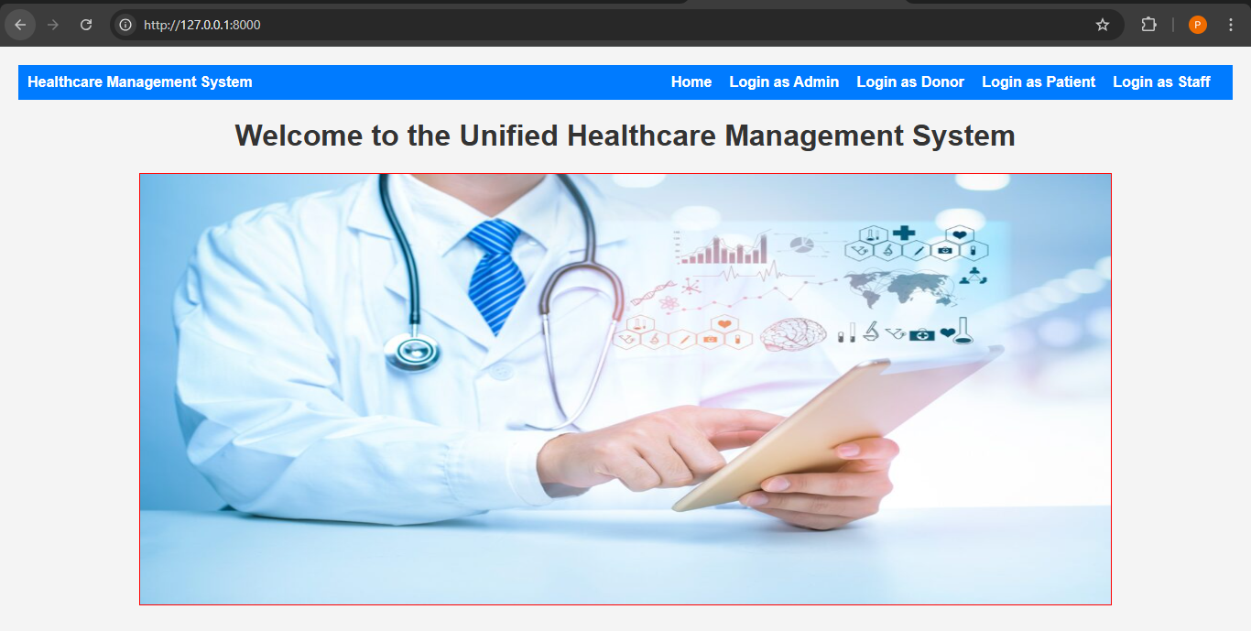
Fig 10.1 Home Page
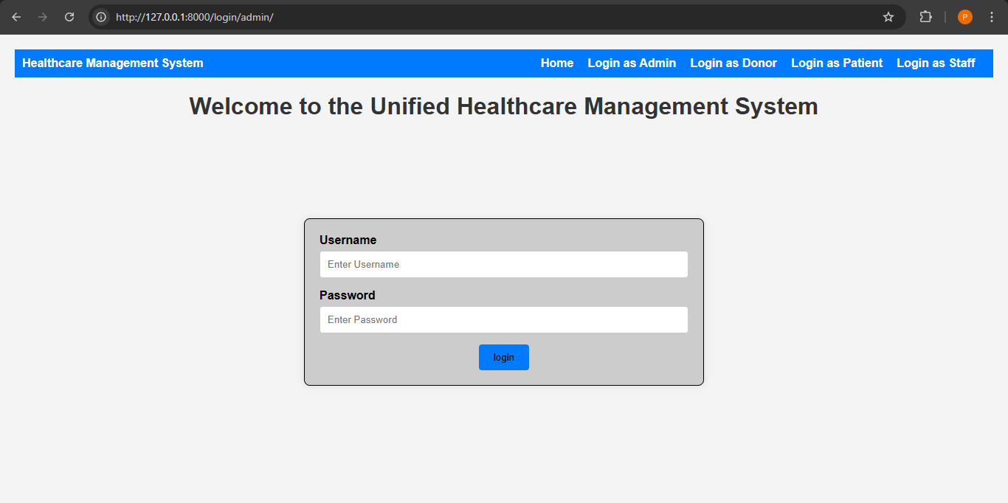
Fig 10.2 Login Page Admin/Staff/Patient/Donor
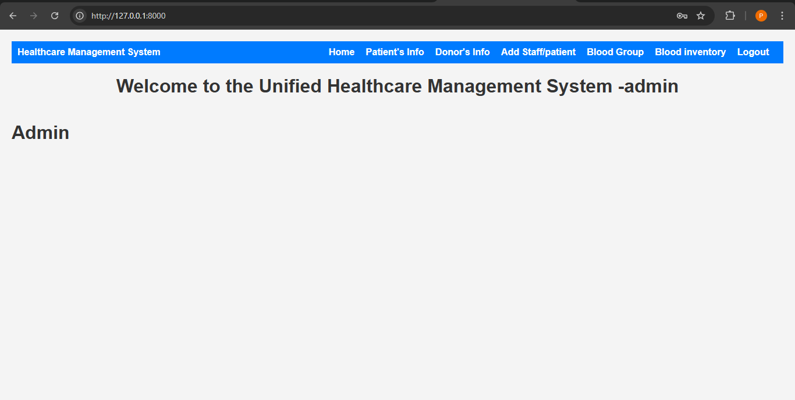
Fig 10.3 Admin Dashboard
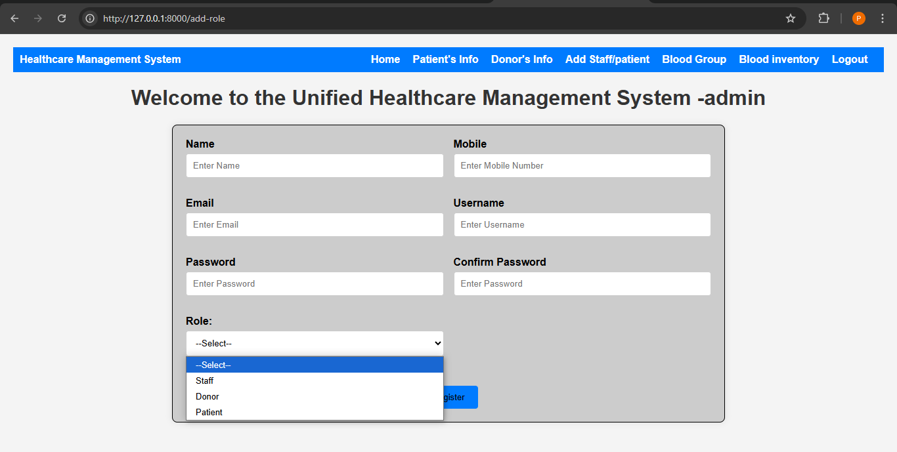
Fig 10.4 Add patient/Staff/Donor
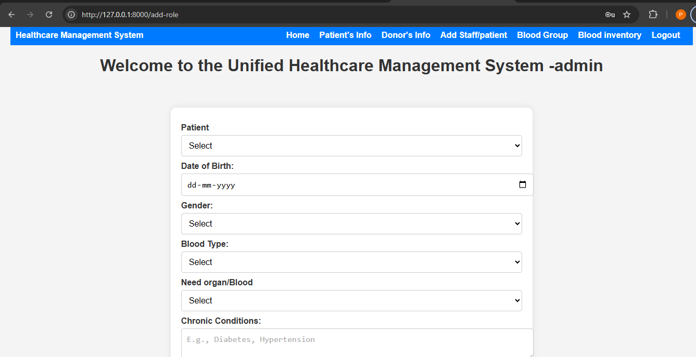
Fig 10.5 Patient Additional Information
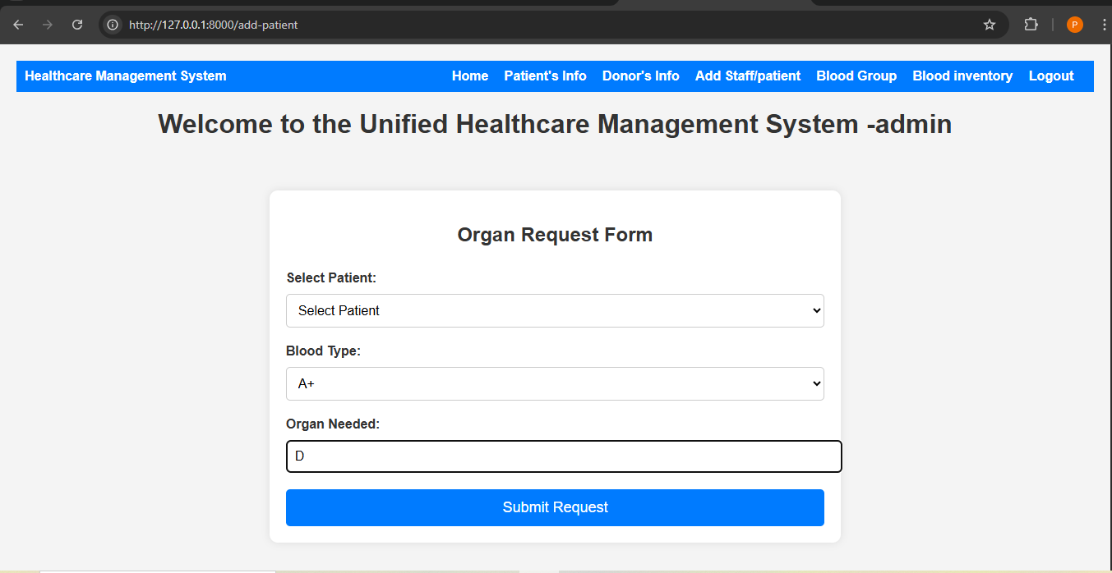
Fig 10.6 Organ Request Form
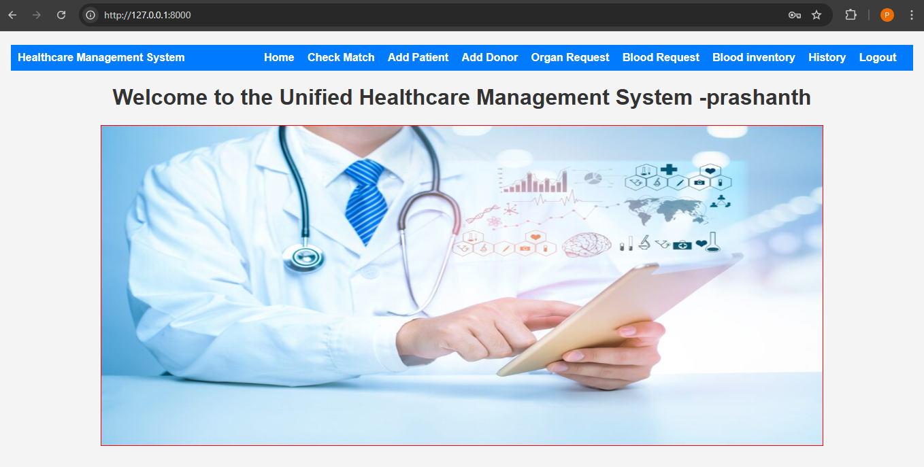
Fig 10.7 Staff Login
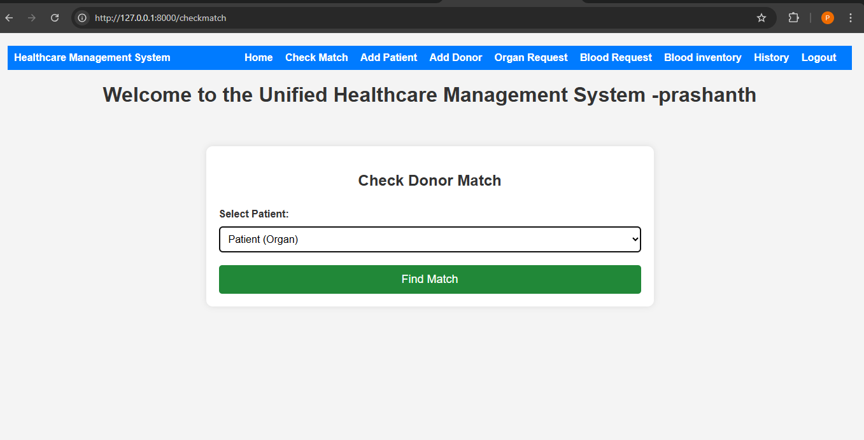
Fig 10.8 Request for Organ

CHAPTER 11
CONCLUSION AND FUTURE SCOPE
11.1 Conclusion
The Unified Healthcare Management System provides a comprehensive digital platform to streamline and integrate various aspects of patient and donor management, organ and blood donation workflows, and hospital resource coordination. Built using Django, this system supports secure user authentication, role-based access, and dynamic interfaces tailored for patients, donors, and healthcare administrators.
Through this platform, patients can easily register and request blood or organ donations, while donors can enroll and express their willingness to contribute. The system automates donor-patient matching based on blood type and organ compatibility, reducing manual efforts and expediting the matching process. Hospital staff can monitor inventory levels, manage requests, and track the status of donations and matches through dedicated dashboards. The use of Django’s robust model-view-template (MVT) architecture ensures maintainability and scalability of the application. Each module—ranging from user registration to real-time request monitoring—has been designed with a clear separation of concerns, which enhances security, efficiency, and ease of updates. Additionally, features like patient and donor information storage, role-based login, and acceptance mechanisms for donation matches strengthen the practical utility of the system.
By digitalizing the healthcare donation workflow, this platform significantly improves accessibility and transparency in critical processes. It removes barriers that often delay organ and blood transplants by offering a centralized space where users and hospitals can interact securely and efficiently. The integration of request approvals and match-check functionalities helps in decision-making and provides a clear picture of availability, demand, and status.
11.2 Future Scope
The system can be enhanced by integrating real-time communication between patients, donors, and hospitals using chat or video consultations. Blockchain technology could be incorporated to secure medical records and consent forms. Additionally, integrating external APIs from government health databases would allow for automated verification of patient or donor eligibility. A mobile application version can also be developed to improve accessibility and user engagement. AI-based donor-patient match prediction and predictive analytics on inventory shortages could further elevate the platform’s efficiency.

REFERENCES
- Ganikos M. Organ donation: an overview of the field. In: Siegel JT, Alvaro EM, editors. Understanding Organ Donation: Applied Behavioral Science Perspectives. Hoboken, NJ: Wiley-Blackwell; 2010. pp. 13–39.
- U.S. Department of Health and Human Services. Organ procurement and transplantation network. Optn.transplant.hrsa; 2015.
- Anantachoti P, Gross CR, Gunderson S. Promoting organ donation among high school students: an educational intervention. Progress in Transplantation. 2001;11(3):201–207.
- Birkimer JC, Barbee AP, Francis ML, Berry MM, Deuser PS, Pope JR. Effects of refutational messages, thought provocation, and decision deadlines on signing to donate organs. Journal of Applied Social Psychology. 1994;24(19):1735–1761.
- Cantarovich F, Fagundes E, Biolcalti D, Bacqué MC. School education, a basis for positive attitudes toward organ donation. Transplantation Proceedings. 2000;32(1):55–56.
- Carducci BJ, Denser PS, Bauer A, Large M, Ramaekers M. An application of the foot-in-the-door technique to organ donation. Journal of Business and Psychology. 1989;4(2):245–249.
- Kopfman JE, Smith SW. Understanding the audiences of a health communication campaign: a discriminant analysis of potential organ donors based on intent to donate. Journal of Applied Communication Research. 1996;24(1):33–49.
- Kopfman JE, Smith SW, Ah Yun JK, Hodges A. Affective and cognitive reactions to narrative versus statistical evidence organ donation messages. Journal of Applied Communication Research. 1998;26(3):279–300.
- Radecki CM, Jaccard J. Psychological aspects of organ donation: a critical review and synthesis of individual and next-of-kin donation decisions. Health Psychology. 1997;16(2):183–195.
- Smith SW, Morrison K, Kopfman JE, Ford LA. The influence of prior thought and intent on the memorability and persuasiveness of organ donation message strategies. Health Communication. 1994;6(1):1–20.
- Weaver M, Spigner C, Pineda M, Rabun KG, Allen MD. Knowledge and opinions about organ donation among urban high school students: pilot test of a health education program. Clinical Transplantation. 2000;14(4 Pt 1):292–303.

